Lesson 02 Demo 08

Implementing Self-Service Password Reset (SSPR)

Objective: To implement self-service password reset

Tools Required: Azure account

Prerequisites: None

Steps to be followed:
- Create a test user in Microsoft Entra ID
- Configure SSPR for the test user
- Reset SSPR for the test user

Step 1: Create a test user in Microsoft Entra ID

- In the Azure portal, locate the three lines in the top left corner and select Microsoft Entra ID from the options

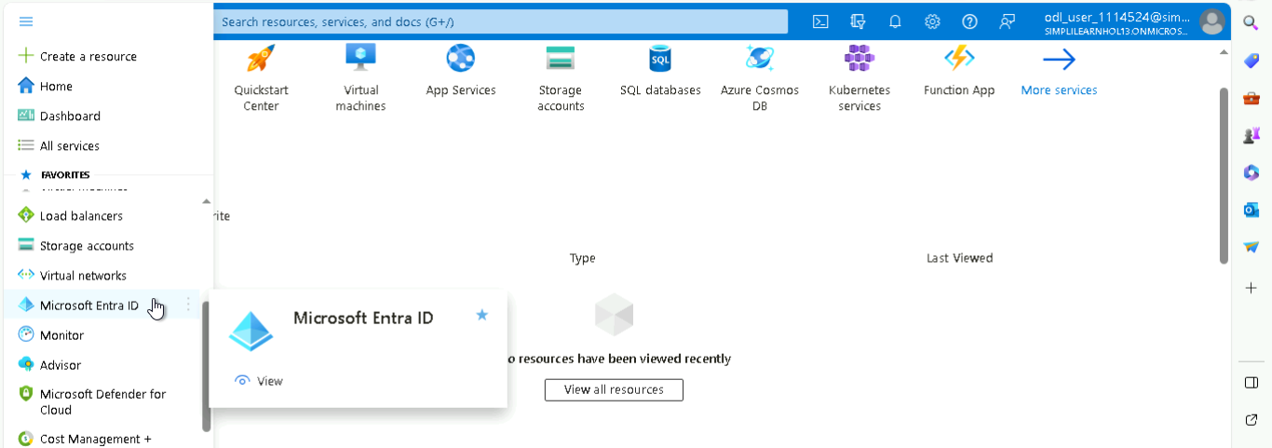

- On the left side, select Users from the options to navigate to the users page

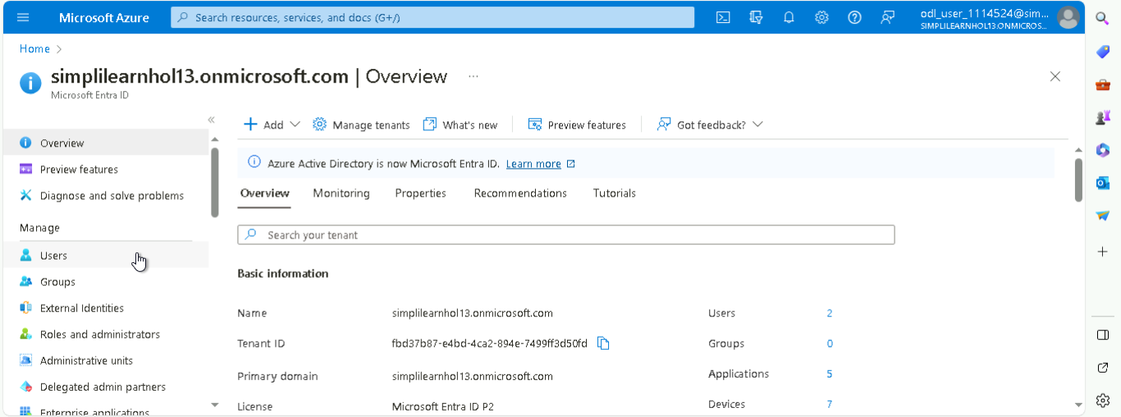

- In the Users page, click on + New user and then choose Create new user

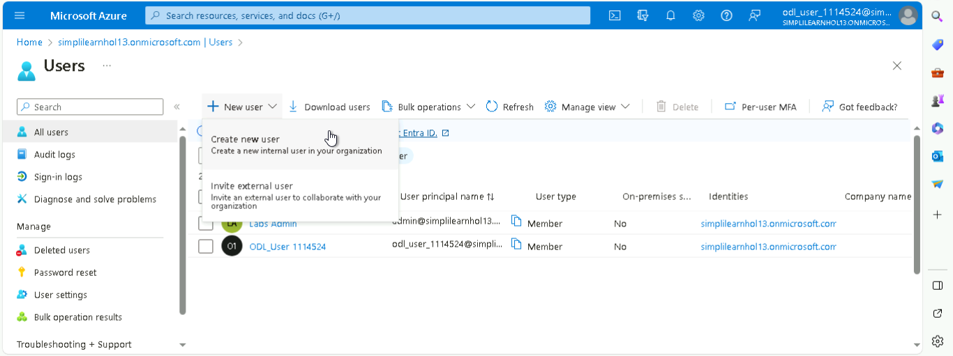

- In the Create new user page, fill in the required details and make sure to copy the
auto-generated password for future sign-ins and click on Review + create

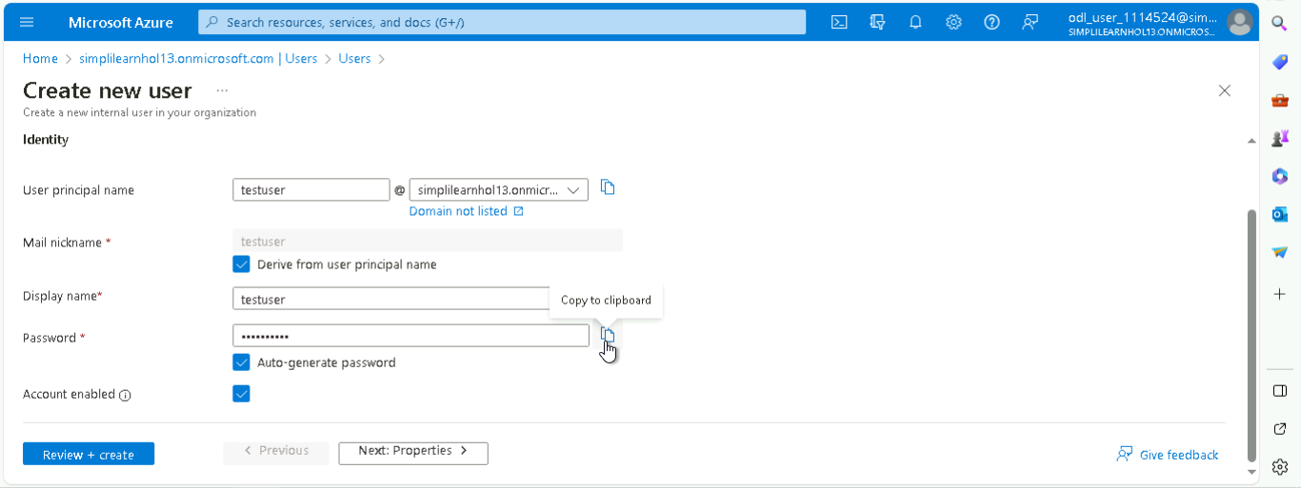

- Click on Create to successfully create a new user

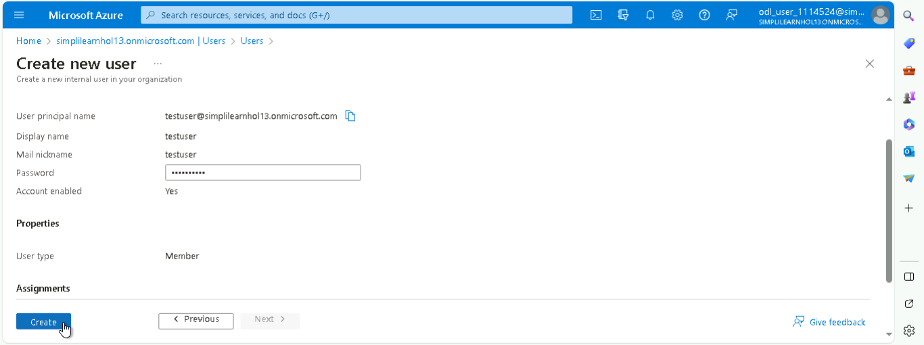

The created user can be viewed under All users in the Users page as shown below:

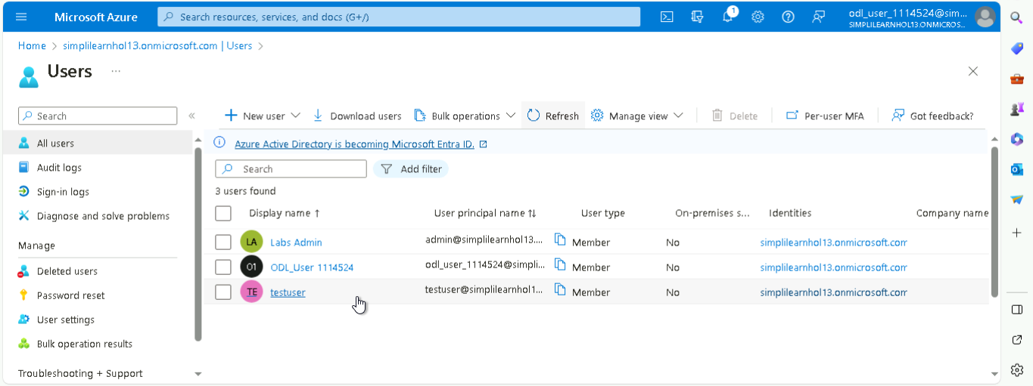

Step 2: Configure SSPR for the test user

  - Navigate to this link: https://entra.microsoft.com/#home

  - Navigate to the left-side options and under Protection, click on Password reset

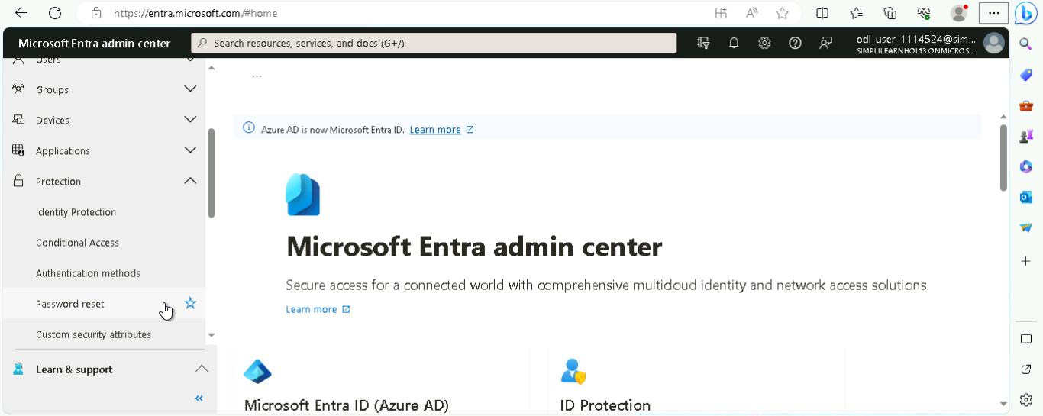

  - In the Properties page under Self service password reset enabled, choose All

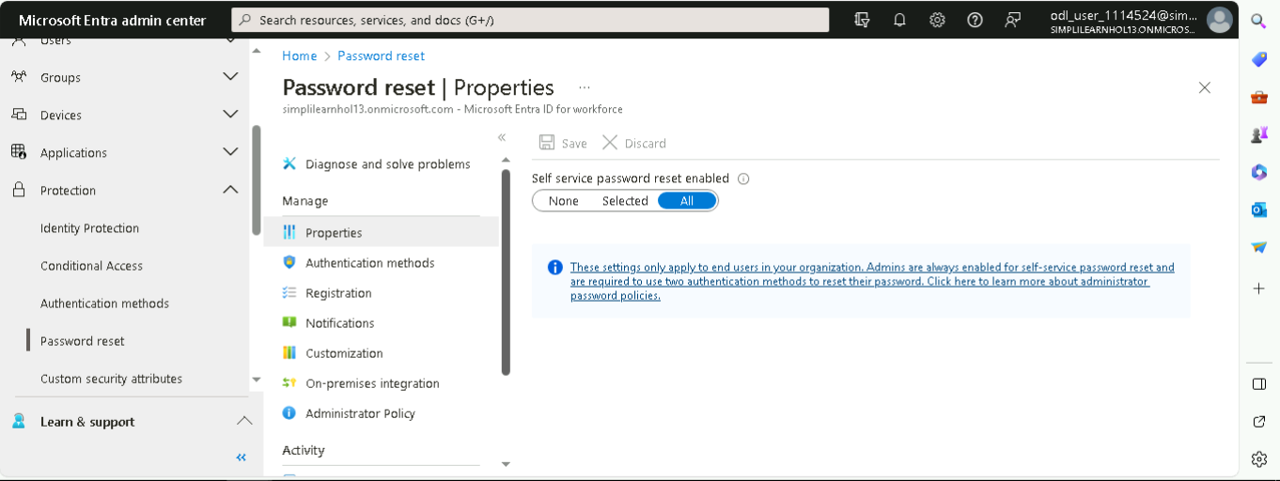

Note:
- Choose All if you want to allow every user to set the SSPR independently
- Choose Selected if you want to permit only specific groups or users to reset their SSPR
- Choose None if you want to restrict all users from resetting their own password, leaving this capability only to admins

Step 3: Reset SSPR for the test user

  - Open a new browser window in InPrivate or Incognito mode and navigate to this link: https://aka.ms/ssprsetup. Then, sign in using the credentials of the test user created

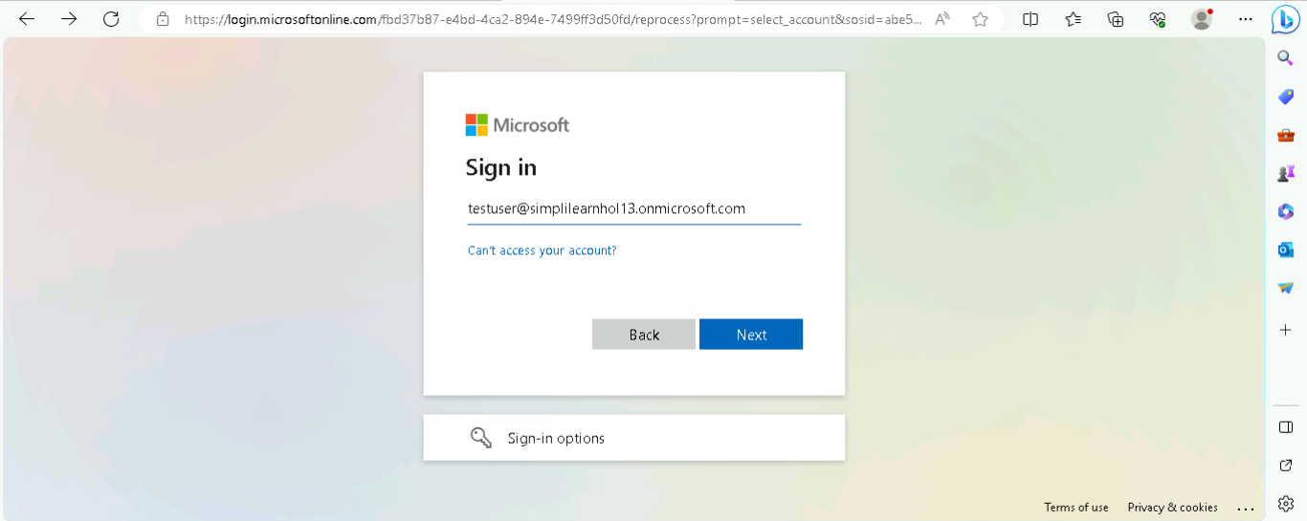

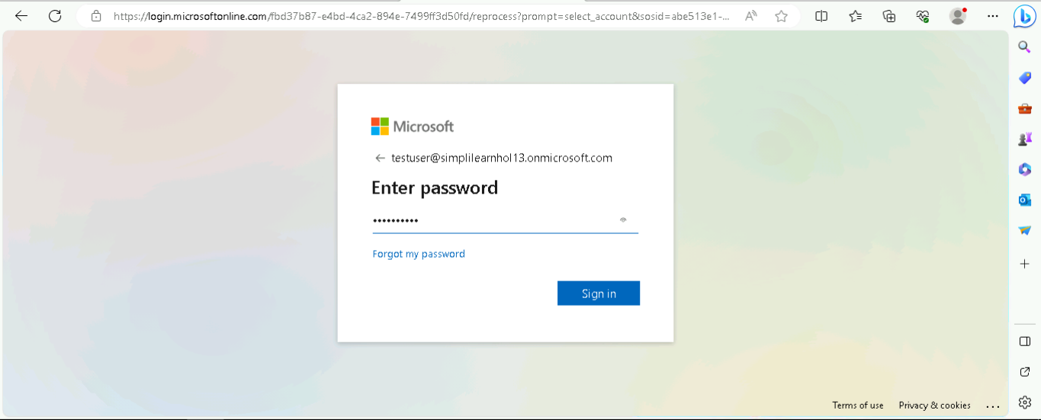

  - Click on Next

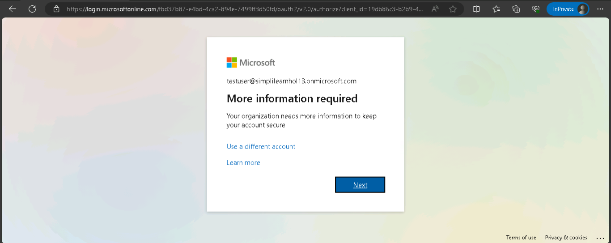

  - Register the user by providing authentication methods and entering the relevant contact information and then click on Next

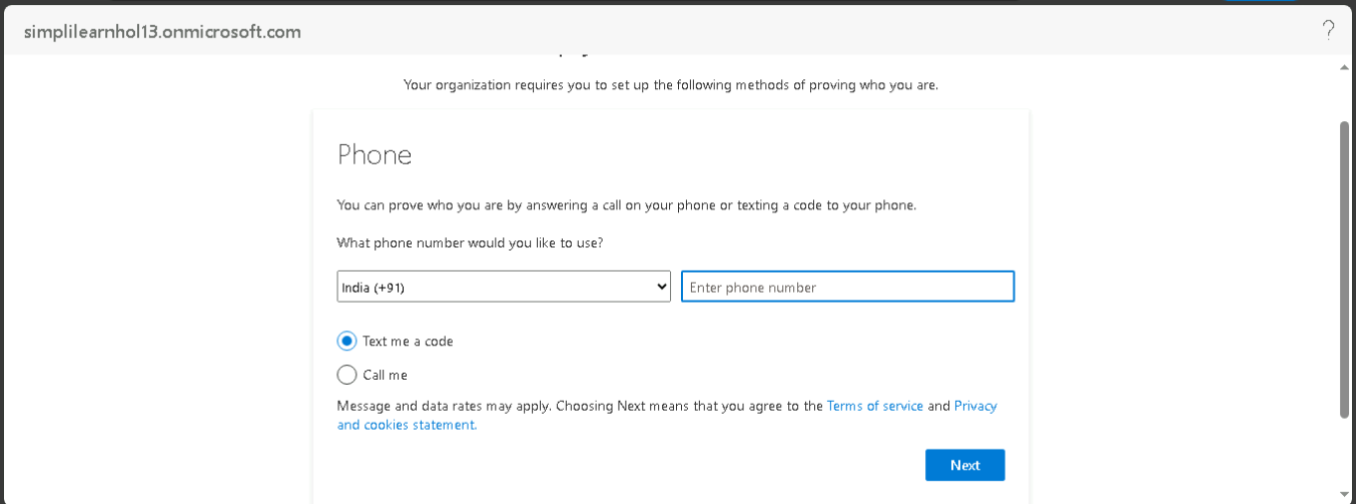

  - After successfully verifying your phone number, click on the Next button

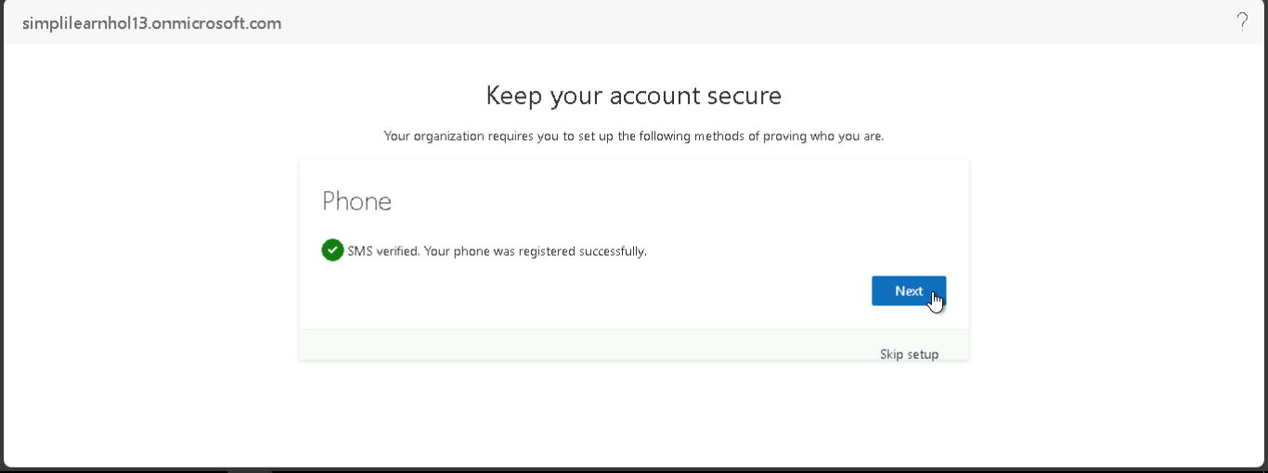

After completing the required authentication, close the browser window.

  - Open a new browser window in InPrivate or Incognito mode and navigate to this link: https://aka.ms/sspr. Enter the required information and click on Next

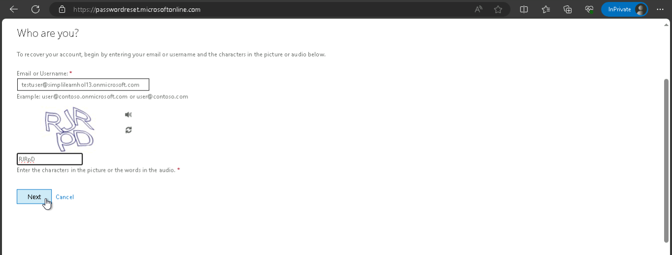

  - Follow the verification steps to reset the password

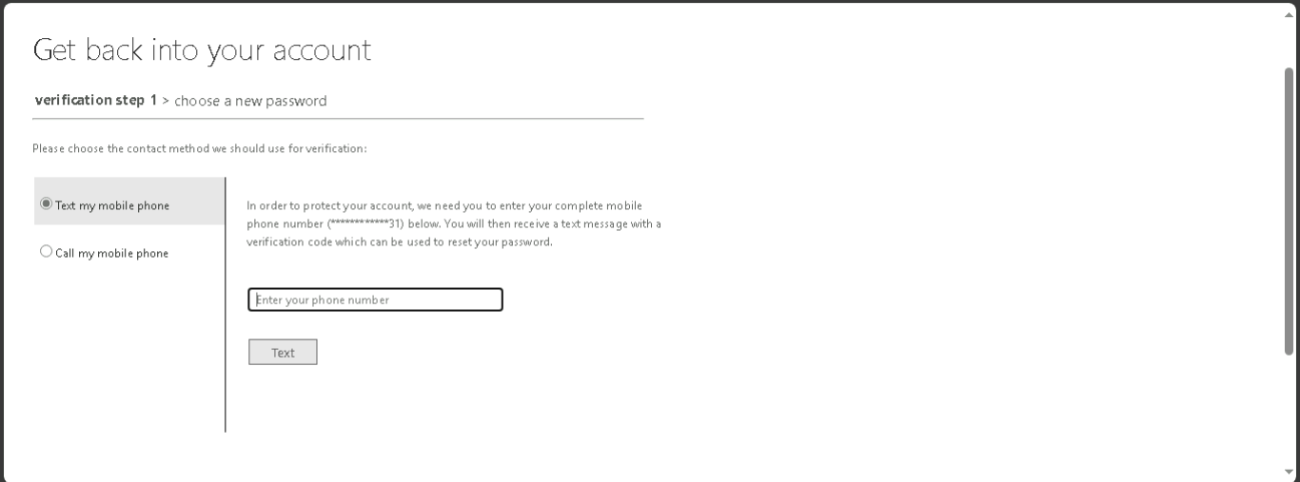

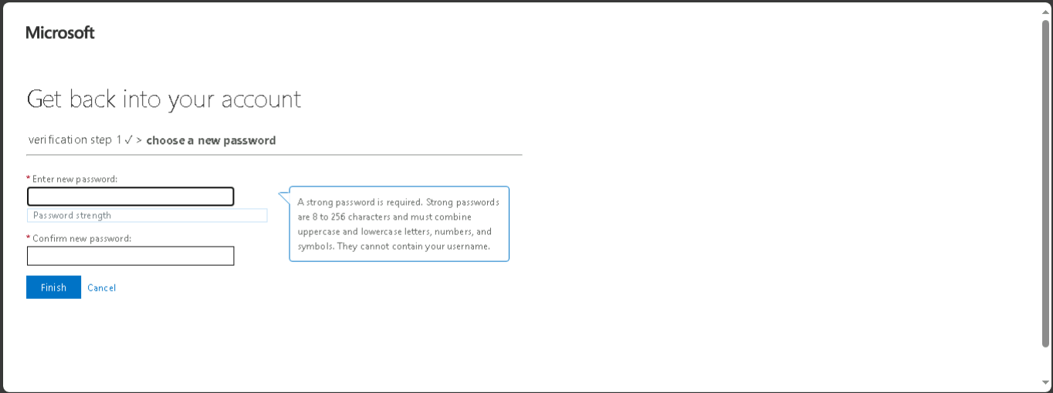

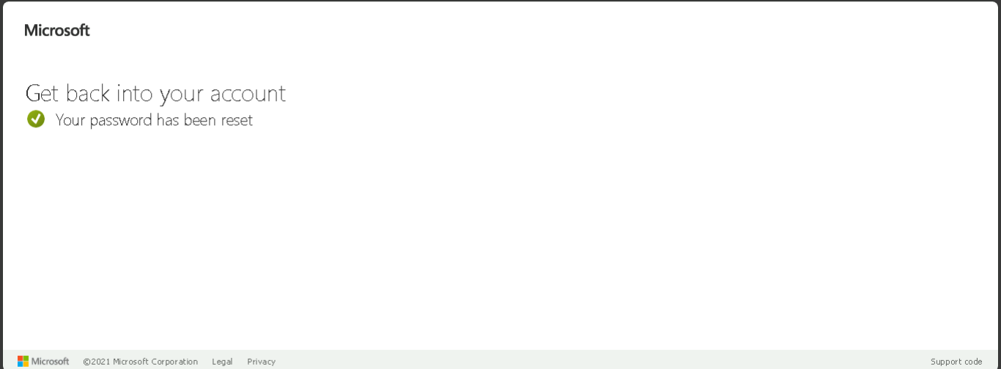

You have successfully reset your password.

